ANIMATRONICS FACE: PROFESSOR JAMES E. JOHNSON

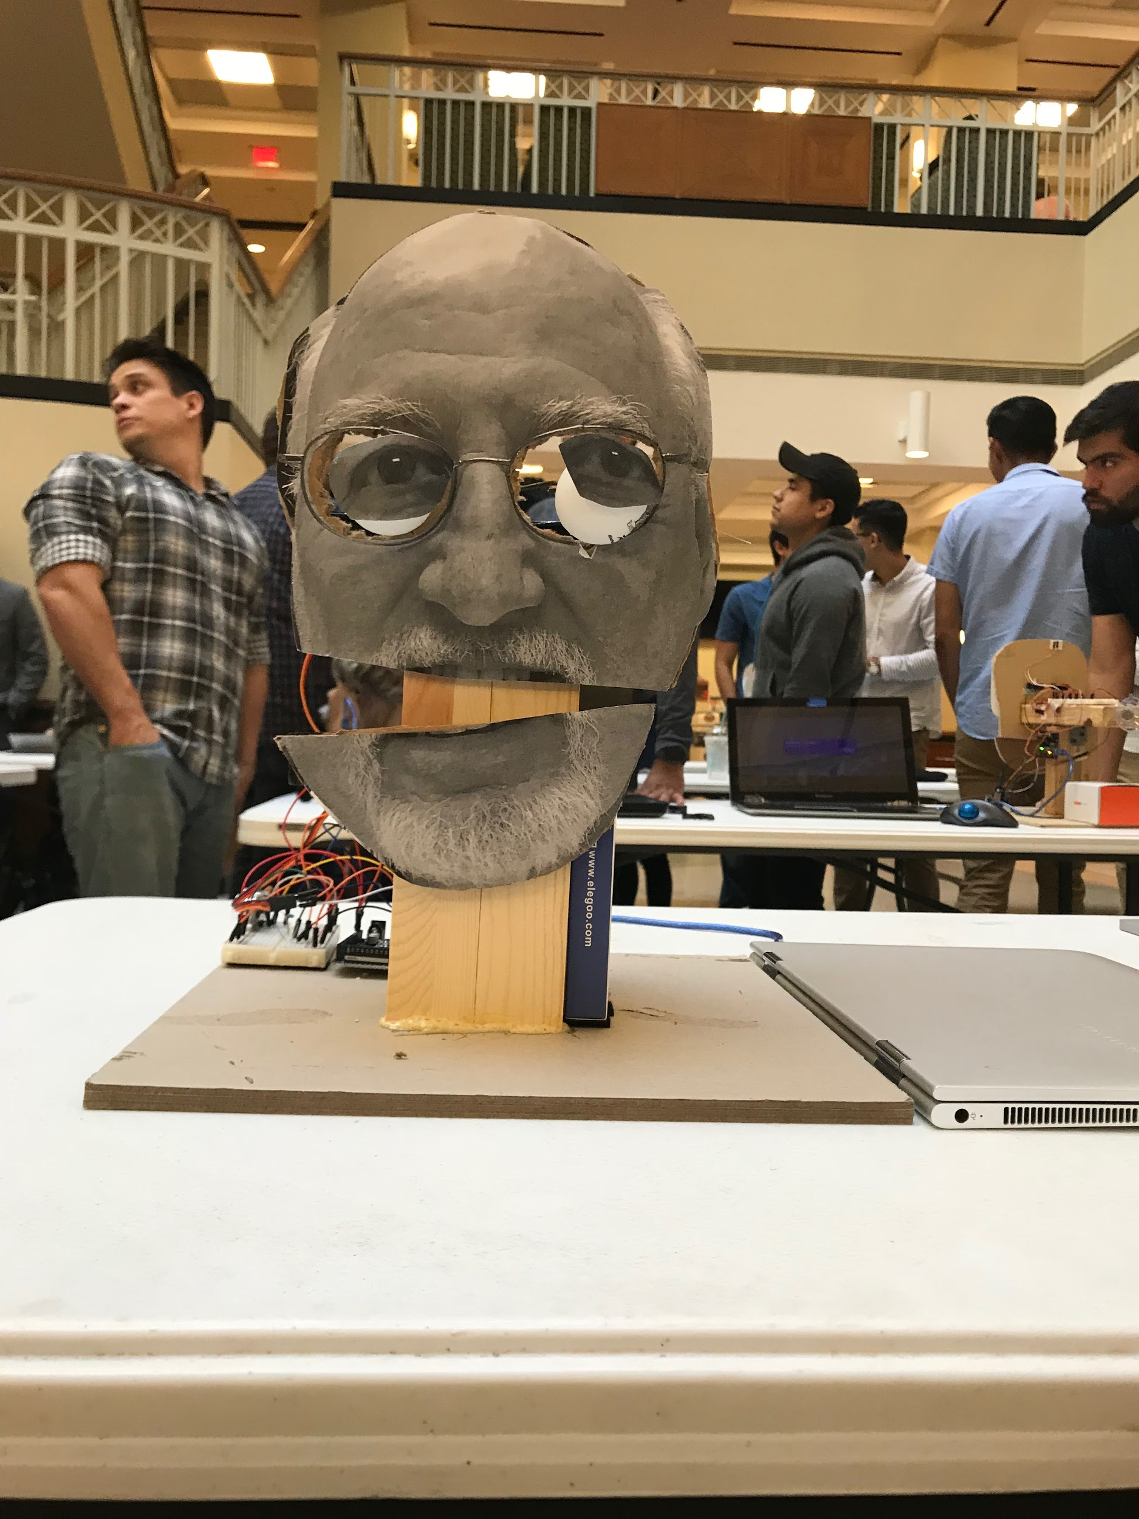

Brandon Donald

Dept. of Mechanical Engineering

San Antonio, TX, USA 78249

bmz2297@gmail.com

Colten Rodriguez

Dept. of Mechanical Engineering

San Antonio, TX, USA 78249

Crodriguezjea@gmail.com

Corey Tong

Dept. of Mechanical Engineering

San Antonio, TX, USA 78249

[coreytong3@hotmail.com](mailto:coreytong3@hotmail.com)

Submitted as part of project for ME4543 Mechatronics, Fall 2018

TABLE OF CONTENTS

|  |  |
| --- | --- |
| Abstract | 3 |
| Literature Review | 4 |
| Supporting Structure | 6 |
| Joints and Motors | 7 |
| Sensors | 8 |
| Programming | 8 |
| Lesson learnt and suggestions | 9 |
| Personnel and Bill of Materials | 9 |
| References | 11 |

**ABSTRACT**

For this project, each team was tasked with the creation of an animatronic face that interacts with the user in a limited way. The professor’s face to be created was assigned randomly to each group (Professor Johnson was assigned to our team). Using at least two different types of sensors, one microcontroller (Arduino Mega 2560) and two actuators (moving parts) for the interactions, we were encouraged to construct a functioning mechatronic device that would speak when prompted. A chassis for the face is to be built, and not bought, out of simple materials such as plywood and cardboard in our case. The animatronic face is also powered by a computer and is completely autonomous once the arduino code/program is running.

**Section 1: Literature review**

An animatronic face of the previous UTSA president was created as shown in “Two college students build a hilarious animatronic face” [3]. The creators utilized Arduino, an erector set, and a set of servos to drive the face, which consisted of the eyes, nose, face, mouth, and moustache. The mouth was also synchronized to an audio clip to mimic speech. This audio clip was originally taken from a YouTube video and was converted from a video file into an audio file and saved into an SD card. The SD card was placed into an MP3 shield and then connected to an Arduino Mega. Code was also written for eye movements. These movements were made by utilizing a ball-socket method--which allowed greater range of motion--for the eye assembly, as well as 4 servo motors (two for each eye). The jaw also utilized a servo motor in conjunction with a zip tie to create a hinge for movement. Lastly, the nose and moustache were constructed in a similar fashion--zip ties and motors were used to allow movement.

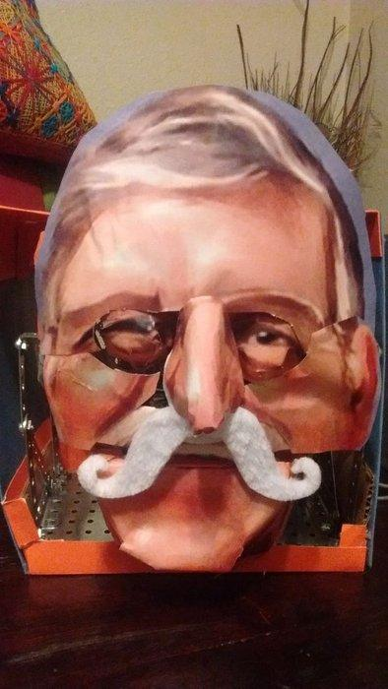

Figure 1: Romobot

A “talking animatronic face” [4] named Robot Head 2 was created to speak at parties, family reunions, elementary schools and conventions. Robot Head 2 is a fairly complex animatronic; The creator of the animatronic used many components such as plywood, wooden knobs for the eyes, doll eyes, latex for the lips/mouth, utilized multiple servos to drive various movements of the head, one servo controller (MiniSSCCII), old computer speakers for the voice, a micro switch, single board computer (RAPU) and compact flash cards to plug into the RAPU for different dialogue and movements. The mouth/lip was synchronized to an mp3 file written in Microsoft Word and then converted into spoken dialogue with a text-to-speech program. Eyebrows and neck movement were also motorized by servos. Sound effects are also added into the dialogue using an audio editor. Programming of the servo controls was unspecified (program/coding language used), however, once all servos are programmed, the control files and mp3 files are put onto a single compact flash card. This card will then be placed into the RAPU for Robot Head 2 to “come alive.”

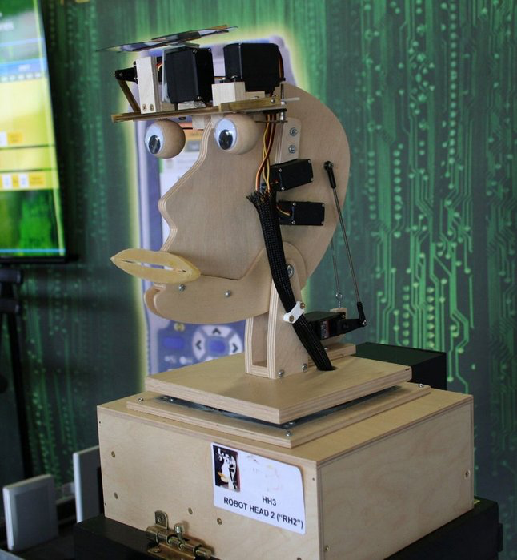

Figure 2: Talking Animatronic Face

Bandit the swashbuckling parrot, as shown in “ANIMATRONICS FOR THE DO-IT-YOURSELFER” [6] was inspired by the Tiki House birds at Disneyland. The specific movements that this parrot was designed to do were to have a synchronized moving jaw with an audio track, nod its head, bend at the waist and have its wings move. Four HiTec 425BB servos were utilized to control movement of the mouth, waist, neck and wings (one servos for each movement, and one for both wings). The framework/skeleton of the parrot was made with aluminum stock. The servos were carefully placed on the aluminum frame where they were attached with bolts, washers and lock nuts. For his voice, a Kitchen Sink controller was utilized which included an audio player and is able to control three servos for body movements. Audio was prepared on Audacity with the original stereo track being split into a right and left channel, where the right channel is replaced with a tone track that drives the jaw/mouth circuit. The Kitchen Sink uses a PICAXE 14M2 processor with an onboard Tenda stereo audio card where an SD card would be placed. The controller when programmed allows for the parrot to be triggered by a passive infrared sensor. The coding for Bandit was written in PICAXE 18M2 and was very basic. After Bandit’s frame and setup was complete, a hand puppet (which was selected before building him) was placed over the frame, mounted onto a wood perch and had his controllers hidden.

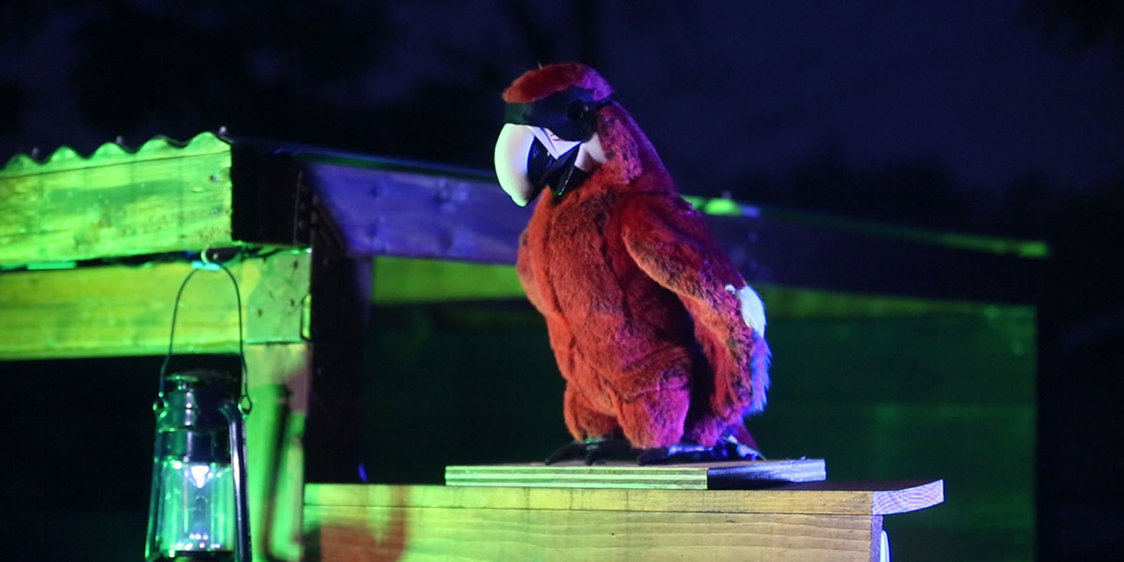

Figure 3: Bandit the Swashbuckling Parrot

**Section 2: Brainstorming (initial planning)**

The animatronics figure will be able to say a set of three different phrases. The parts that will move is the mouth, and the eyes. The eyes will move from left to right, and will be operated by RC servo motors. The sensor will be operated by a frequency based ultrasonic sensor system, if anything passes in front of the given range then the motion and face will speak. The face will be overlayed onto the chassis with the combination of glue, and screws (if necessary) the chassis will be plywood board. The sound track will be synced with the movements by creating a script in Arduino allowing for the movement of the mouth to be in sync with the phrases. The power will be supplied via batteries. The sound track will be in a .mp3/.WAV format via iphone then downloaded onto a computer and uploaded into the arduino to be played via the animatronics head.

**Section 3: Supporting structure**

The supporting structure will be made up of cardboard and plywood. The structure components consist of a (cardboard) base, two pieces of plywood to support facial structures such as the eyes, nose and mouth, and L shaped cardboard pieces to support the plywood. The plywood and L shaped cardboard pieces will be glued together and attached to the base as shown in Figure 4. The eyes, nose, mouth and joint components will be assembled and coded/programmed before attaching them in the proper spots on the front of the frame. Once that is completed, electrical components, wiring and the motors will be attached to the base of the frame, behind the face. A paper mache mask will be cut and fitted to the front front of the facial components, and then the face of the assigned professor will be glued onto the mask, creating the shell of the animatronic professor.

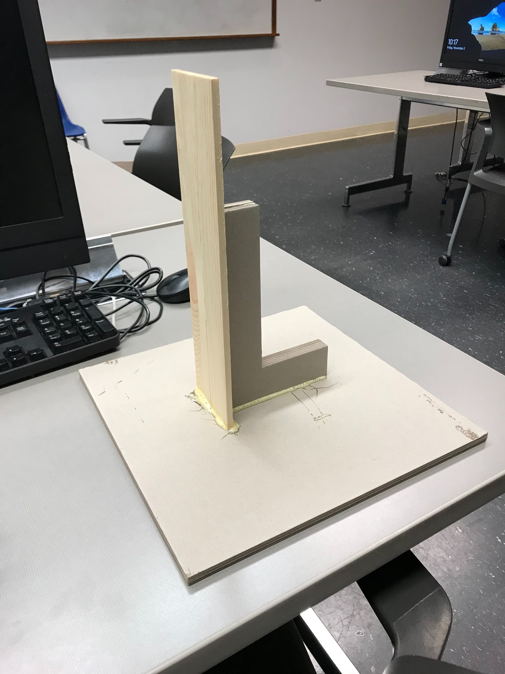

Figure 4: Supporting Structure

**Section 4: Joints and motors**

The joints we decided to have in motion were the eyes and the mouth. The mouth joint was actuated by utilizing a servo motor for the animatronic to speak. The eye joints will also move by utilizing a servo motor for each eye. We chose the servo motor(s) for ease of use, making the mouth move up and down by transversely mounting it to the back of the frame/head, and having the eyes set up to move up, down, left and right.

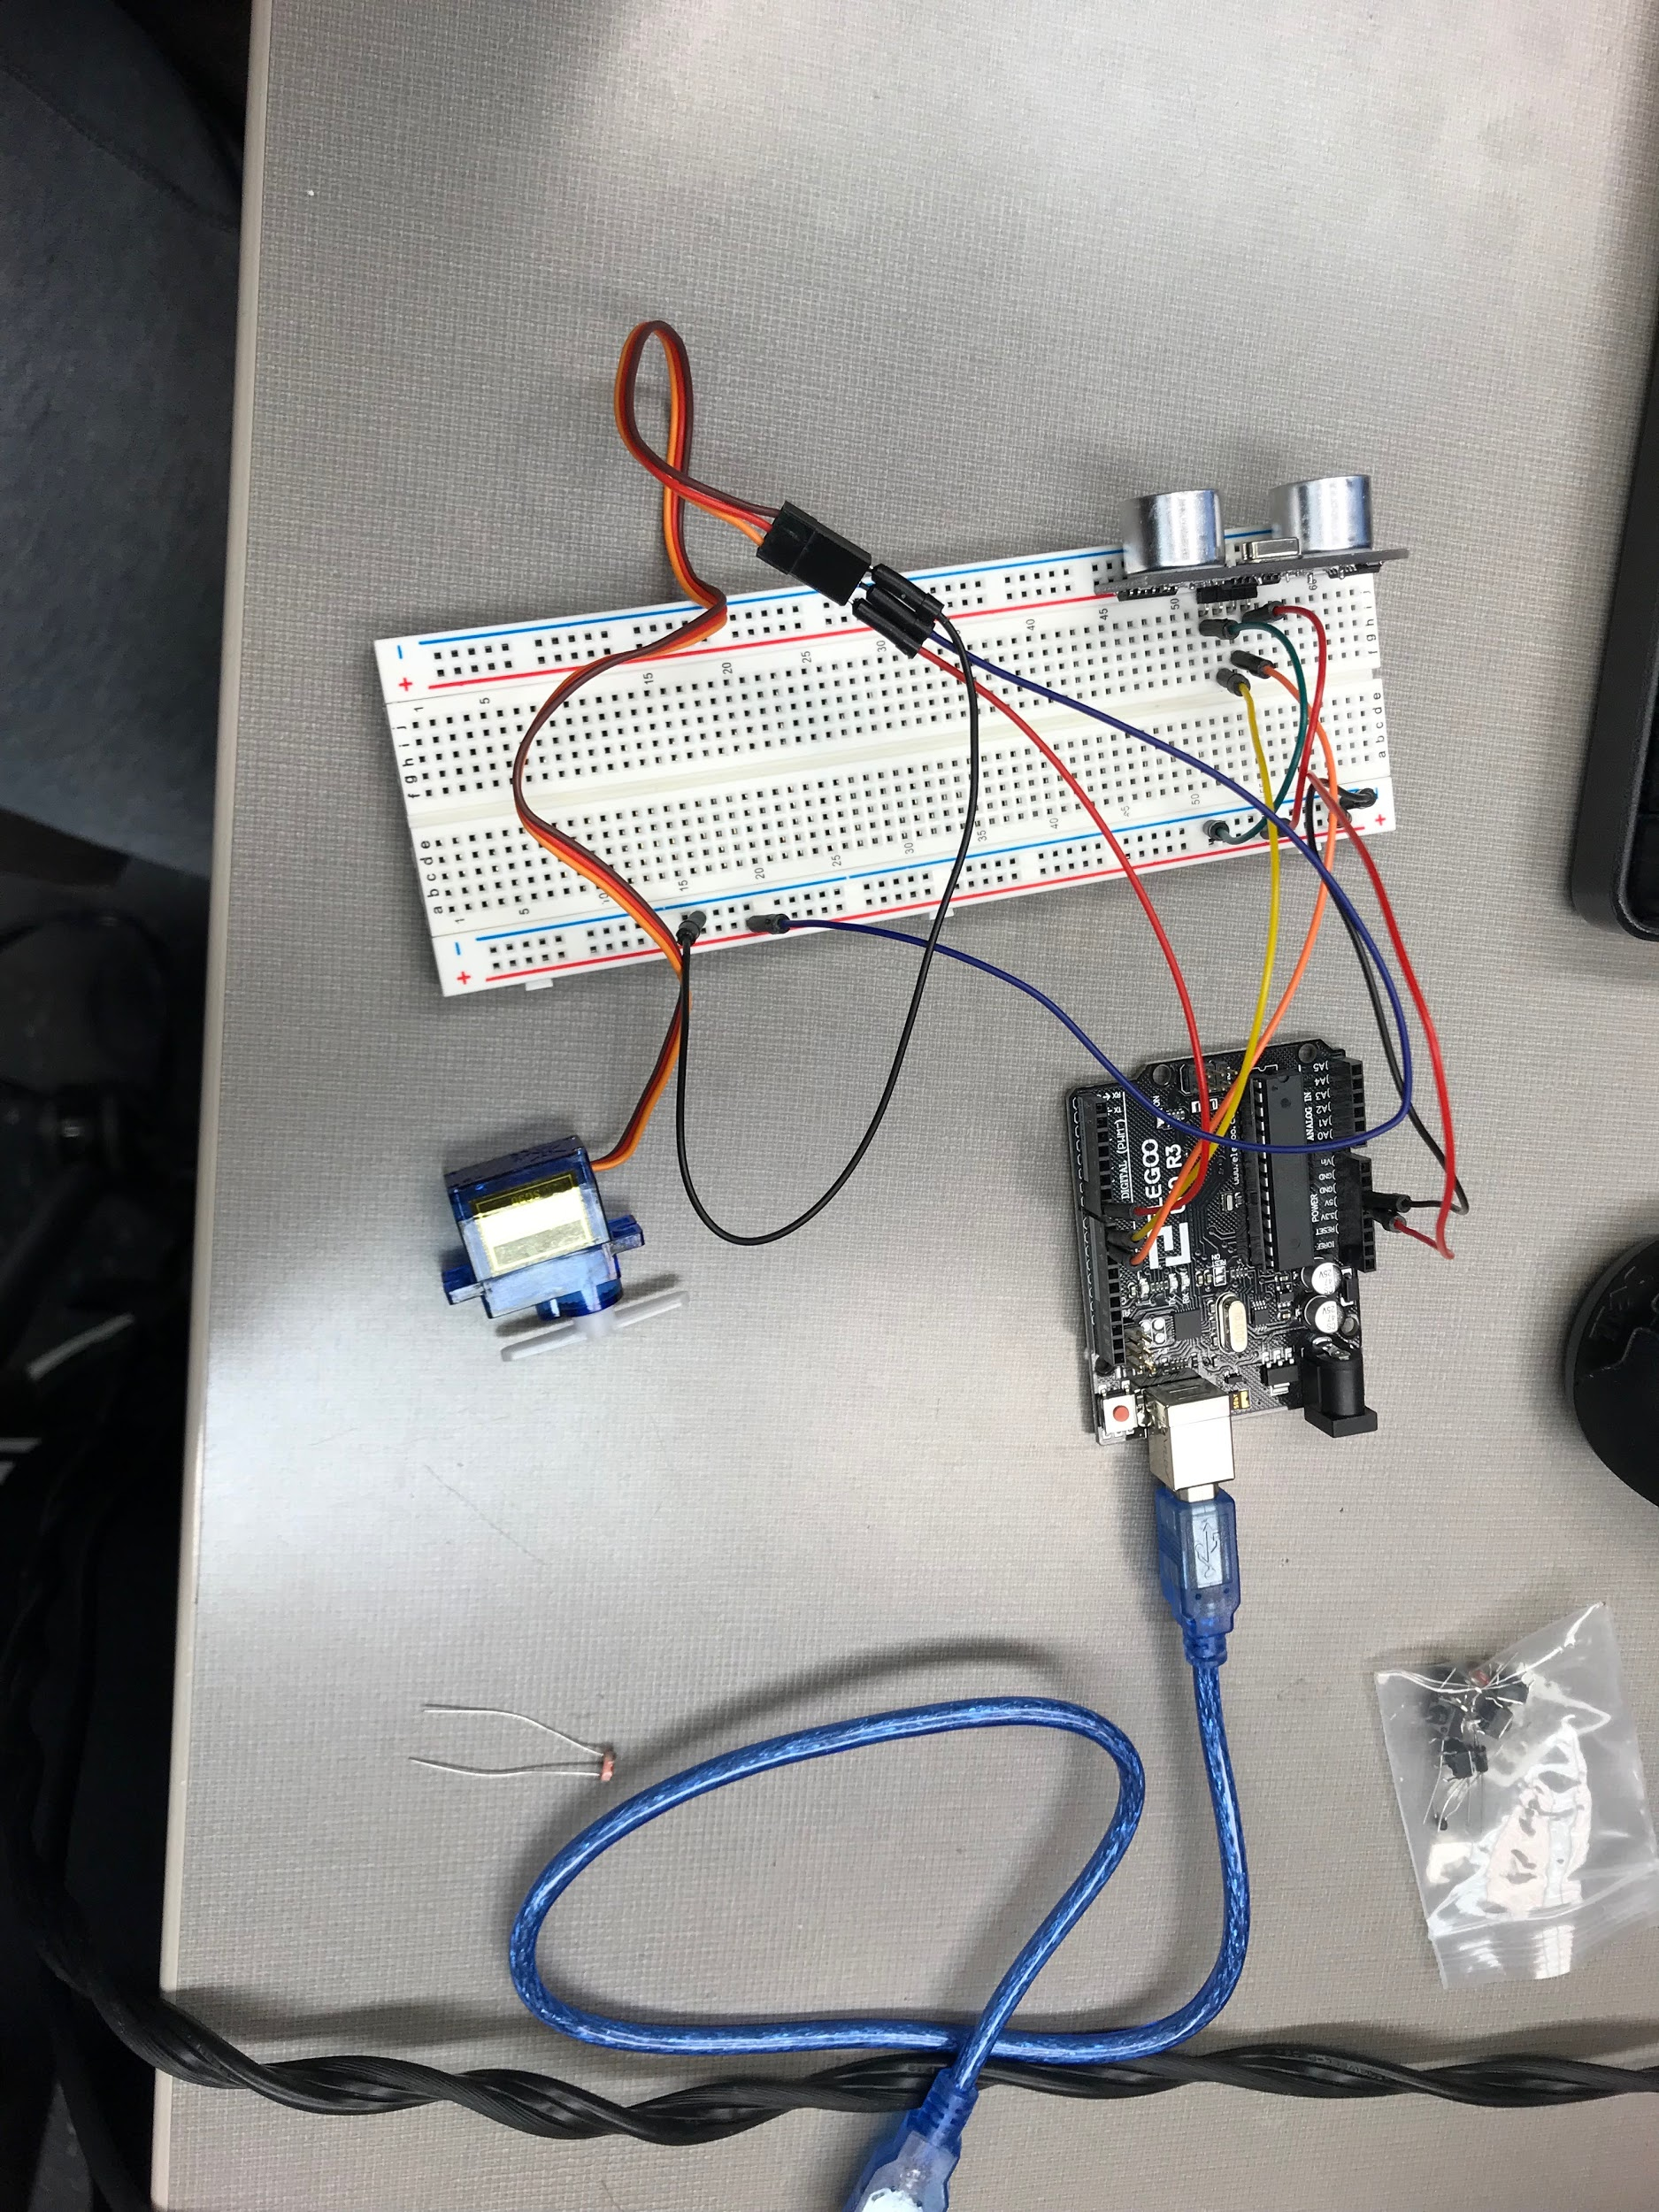

Figure 5: Ultrasonic sensor & mouth servo

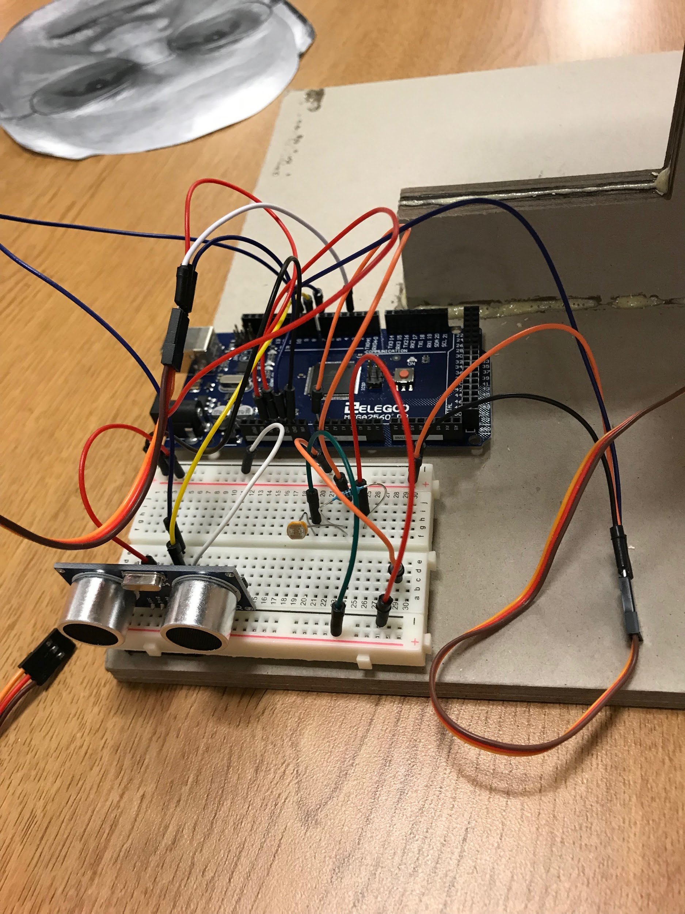

Figure 6: Photoelectric sensor next to Ultrasonic Sensor

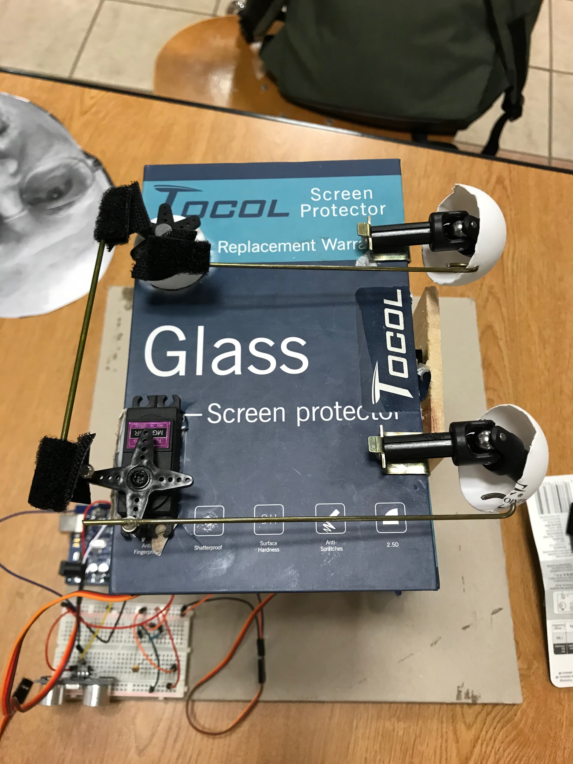

Figure 7: support structure/setup for the eyes

**Section 5: Sensors**

The sensors we chose to utilize were an ultrasonic sensor for the mouth joint and a photosensor for the eye joints. The photosensor will be enclosed and hidden in the mouth to allow it to turn on and off as the mouth opens and closes. The mouth joint will utilize an ultrasonic sensor to have the mouth move up and down when motion is detected within a predetermined distance. Whenever the mouth opens, the eyes will also move (up, down, left and right), as they will be actuated by a photosensor (the light coming into the mouth will activate the eyes; the photosensor will be enclosed so that it will not be triggered unless the mouth opens). Ultrasonic sensor was used for ease of operation, and the photosensor being placed in the mouth will allow the eyes to trigger/move at the correct time.

**Section 6: Programming for interaction**

The ultrasonic sensor sends a signal to the Arduino when it detects movement/an object within 10 cm. This triggers the mouth to move. The Arduino sends a signal to a servo motor to rotate 60 degrees, wait 200 milliseconds, reverts back to its initial position of 0 degrees, and waits another 200 milliseconds. This process repeats for a total of 3 repetitions to simulate mouth movement.

A photoresistor cell is also used to trigger movement; in this case, it triggers eye movement. When the photoresistor input signal is less than 300, the Arduino sends a signal to the servo motor that controls the eyes.

**Section 7: Lessons learnt and suggestions**

1. Learning to code a servo motor to activate with a photoresistor
2. Learning to code a servo motor to activate with a ultrasonic sensor
3. Building from scratch a way to rotate the mouth of the project to be in sync with the spoken words of the professor
4. Building from scratch a way to rotate the eyes from left to right using a servo motor to rotate
5. Applying the joints to work in unison with the applied input (mouth and eyes)
6. A body for the face to rest on and how the components of the design is attached
7. Learning where to buy specific components of the animatronics project and which areas are cheapest/reliable
8. Working together with partners to come to consensus of what needs to be build and who will do what tasks
9. Learning to wire into the Arduino MEGA 2560 a servo motor and a photoresistor
10. Learning to wire into the Arduino MEGA 2560 a servo motor and a ultrasonic sensor
11. How to attach components to a base in a simple manner without showing components of the design on the face

The initial start of the project was difficult due to the components being bought from unknown websites. The components bought were relatively cheap compared to other websites however the shipping time was very long for these parts. The base was built initially but due to the long shipping times parts slowly trickled in on the 3rd week of the project. Another problem of the design was that the components that came into the design did not all work. A guess and check method was done to find which components worked with the set up. Approximately ⅓ of the products bought did not work and worked partially. The lessons learned from the project includes buying electronics. More often than not spending a slightly larger amount of money allows for components to work and ship on time, rather than spending slightly less to have broken components and long shipping times. Another lesson learned was how to wire and code properly without burning out the components or wires of the design. One servo was burned out from not wiring properly and understanding how to wire properly will fix any errors/unnecessary costs of the design.

**Section 8: Personnel and bill of materials**

**(a) Personnel**

|  |  |  |
| --- | --- | --- |
| Task | Main Personnel | Secondary personnel |
| Supporting Structure (& Face) | Colten | Corey |
| Joints - Eyes | Colten | - |
| Joints - Mouth | Brandon | Corey |
| Motor Interfacing | Corey | Colten |
| Sensor Integration/Interface | Corey | Brandon |
| Programming | Brandon | Colten |

**(b) Bill of materials**

|  |  |  |  |  |  |
| --- | --- | --- | --- | --- | --- |
| No. | Description | Website/comment | Qty. | Unit $ | Total $ |
| 1 | Arduino MEGA 2560 | Provided | 1 | 0 | 0 |
| 2 | Base | Bought | 1 | 8 | 8 |
| 3 | Plywood | Bought | 2 | 1 | 2 |
| 4 | L piece | Bought | 2 | 4 | 8 |
| 5 | Cardboard box | Bought | 1 | 1.78 | 1.78 |
| 6 | Velcro stickers | Bought | 1 | 5 | 5 |
| 7 | Servo motors 9g | Bought | 2 | 6.50 | 13 |
| 8 | ultrasonic sensors | Bought | 5 | 2 | 10 |
| 9 | RC driveshaft | Bought | 2 | 8 | 16 |
| 10 | RC motors | Bought | 2 | 15 | 30 |
| 11 | Fishing Wire | Bought | 1 | 5.94 | 5.94 |
| 12 | Arduino Shield | Bought | 1 | 5.99 | 5.99 |

The total price for this project excluding the Arduino MEGA was: $105.71

**References:**

# [1] Animatronics Face of UTSA's President, Dr. Ricardo Romo, <https://youtu.be/xkze1_hnam0>

# [2] ROMOBOT - ANIMATRONIC FACE ROBOT

# <https://www.instructables.com/id/RomoBOT-Animatronic-Face-Robot/>

[3] Two college students build a hilarious animatronic face <https://blog.arduino.cc/2016/05/13/two-college-students-build-a-hilarious-animatronic-face/>

[4] TALKING ANIMATRONIC ROBOT HEAD <https://www.instructables.com/id/Talking-Animatronic-Robot-Head/>

[5] Robot Head 2 <http://www.youtube.com/watch?v=AhPnrvdMArM>

[6]ANIMATRONICS FOR THE DO-IT-YOURSELFER <https://www.servomagazine.com/magazine/article/June2015_Koci>